A binary tree is *univalued* if every node in the tree has the same value.

Return true if and only if the given tree is univalued.

**Example 1:**

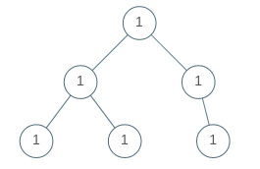

**Input:** [1,1,1,1,1,null,1]

**Output:** true

**Example 2:**

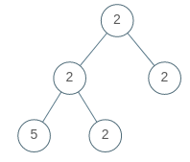

**Input:** [2,2,2,5,2]

**Output:** false

**Note:**

1. The number of nodes in the given tree will be in the range [1, 100].
2. Each node's value will be an integer in the range [0, 99].